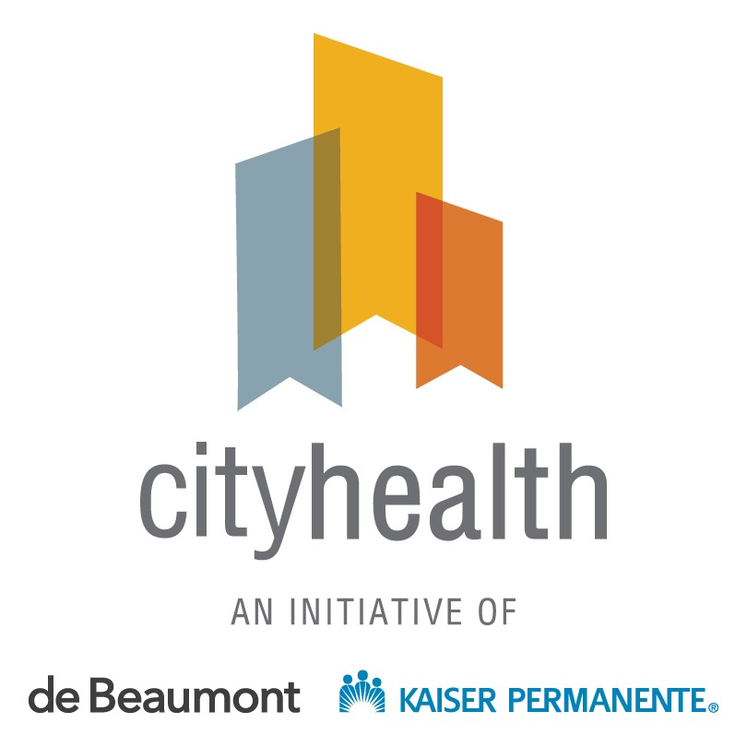

2021 Report Messages

On Overall 2021 Results:
- Today, more than 44 million people live in a city that has earned an overall CityHealth medal. Thanks to the incredible leadership and resilience of city leaders and local public health officials, millions of people are benefitting from policies that provide access to a safe place to live, a healthy body and mind, and a thriving environment.
- America’s largest cities have reached a new milestone in public health: 37 out of the 40 largest U.S. cities received top marks for adopting policies that improve people’s health.
  - The fact that 92.5% of cities have earned an overall CityHealth medal shows that city leaders are committed to health and equity in their communities as they continue to navigate the many challenges related to the COVID-19 pandemic and the rapidly shifting economic landscape.
- This is the highest percentage of cities to earn an overall CityHealth medal since the initiative began its annual ratings in 2017, with the results coming in slightly ahead of 2020 (90%) and nearly double the number from the 2017 assessment (47.5%).

A Look Back at CityHealth’s Inaugural Policy Package
- Over the past five years, CityHealth has worked with cities to rethink how ‘health’ is different from ‘health care’ and to advance upstream, prevention-oriented policies that improve health outcomes for the community as a whole.
  - We congratulate the local leaders who have joined us in the movement for health by expanding access to healthy choices that can help their residents thrive for decades to come.
- The 2021 policy assessment is the final time CityHealth will assess cities on its inaugural package of nine policy solutions. Several CityHealth policies, such as Complete Streets and smoke-free indoor air, have seen a remarkable rate of adoption.
- Tobacco 21 stands out as an exemplar story of policy success — growing from just 13 cities earning medals in 2017 to all 40 cities earning medals in 2019. This remarkable achievement was the result of locally driven innovation that ultimately became the law of the land.
- Starting in 2022, CityHealth will assess cities on a new package of 12 policy solutions. This expanded policy package, developed with feedback from city leaders and after a comprehensive review of the latest data and evidence on effective policy solutions, sets a new gold standard for cities to aspire to and is designed to be responsive to the evolving challenges cities face today.
- CityHealth is growing its footprint in 2022 by including the nation’s largest 75 cities in its annual policy assessment. We look forward to working with new city leaders and expanding our impact. Visit CityHealth.org for a complete list of the new policies and the cities we’re working with.

About CityHealth
- CityHealth, an initiative of the de Beaumont Foundation and Kaiser Permanente, works to advance a package of tried and tested policy solutions that ensure all people in the largest U.S. cities have access to healthy choices — and the opportunity to live healthy, full lives.
- Together, with visionary city leaders, we can make sure all people have a safe place to live, a healthy body and mind, and a thriving environment.
- Each year, cities are awarded gold, silver, and bronze medals according to the strength and number of the policies they have in place.

